**Google Tag Manager (GTM)**

Google Tag Manager is a free tool that allows users to manage and deploy marketing tags on their websites.

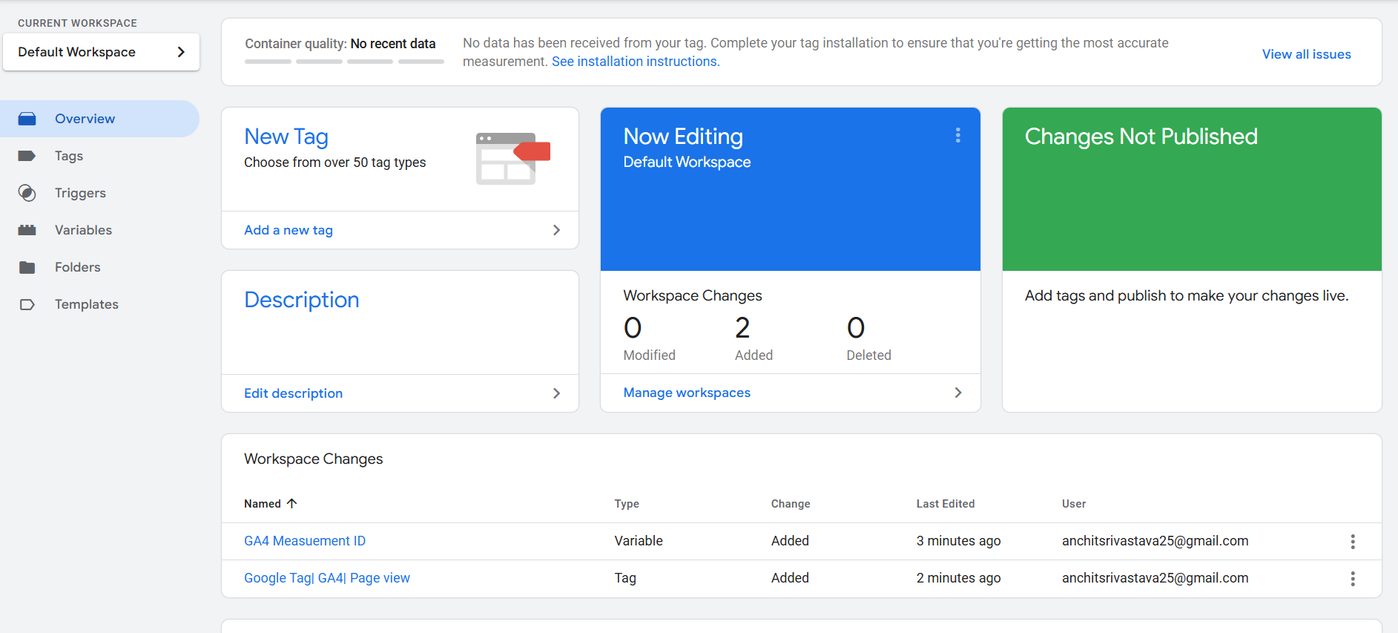

I created a Google Tag Manager (GTM) workspace, added a tag, and configured it to track clicks on your website. This data is now being sent to Google Analytics (GA), allowing me to monitor and analyze user interactions.

**Google Analytics (GA)**

Google Analytics is a powerful tool that allows me to track and analyze website traffic, user behavior, and conversions. It provides insights into visitor demographics, page performance, and user interactions to optimize my page.

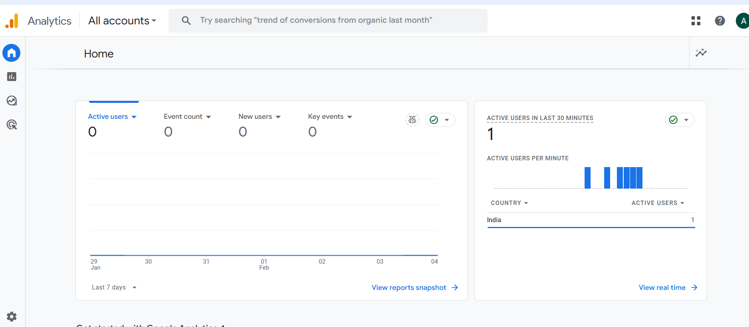

Here, on the home page of Google Analytics I can see the active users in the last 30 minutes(which is me right now).